**WEEK 5**

**CREATING MICROSERVICES FOR ACCOUNT AND LOAN**

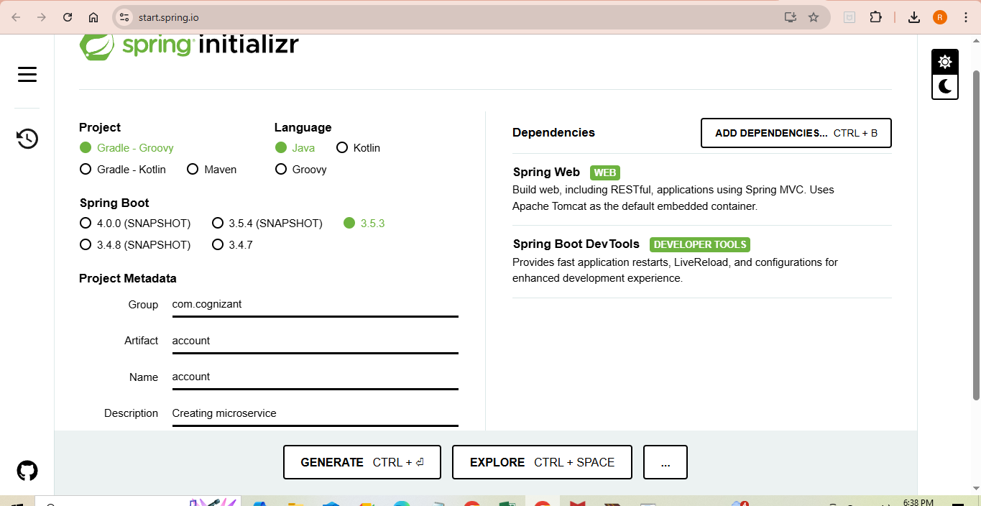

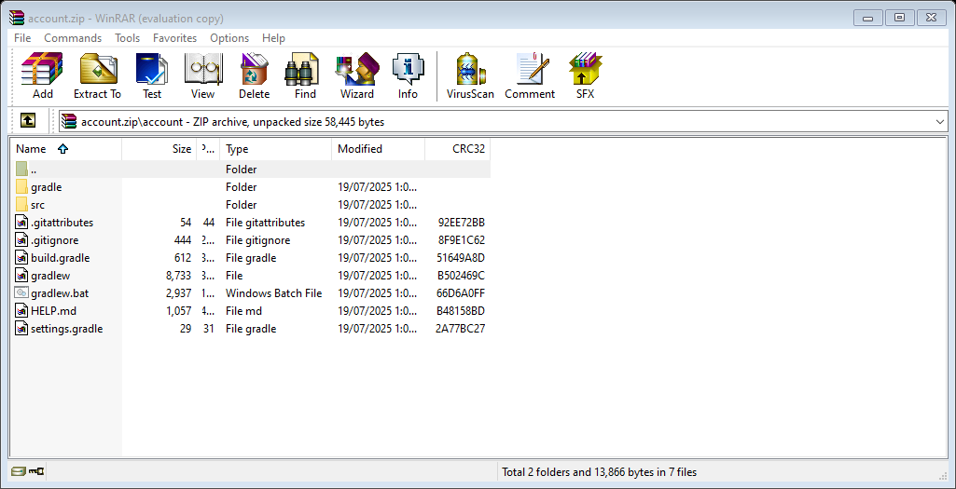

**IMPLEMENTATION :-**

GET/ accounts/ {number}

Sample response :

{

"number": "00987987973432",

"type": "savings",

"balance": 234343

}

**For Loan,**

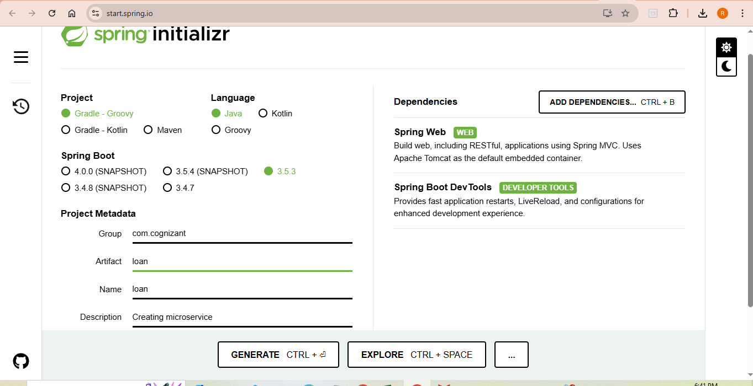

In loan.zip,

**build.gradle**

plugins {

id 'java'

id 'org.springframework.boot' version '3.5.3'

id 'io.spring.dependency-management' version '1.1.7'

}

group = 'com.cognizant'

version = '0.0.1-SNAPSHOT'

java {

toolchain {

languageVersion = JavaLanguageVersion.of(21)

}

}

repositories {

mavenCentral()

}

dependencies {

implementation 'org.springframework.boot:spring-boot-starter-web'

developmentOnly 'org.springframework.boot:spring-boot-devtools'

testImplementation 'org.springframework.boot:spring-boot-starter-test'

testRuntimeOnly 'org.junit.platform:junit-platform-launcher'

}

tasks.named('test') {

useJUnitPlatform()

}

**LoanApplication.java**

package com.cognizant.loan;

import org.springframework.boot.SpringApplication;

import org.springframework.boot.autoconfigure.SpringBootApplication;

@SpringBootApplication

public class LoanApplication {

public static void main(String[] args) {

SpringApplication.run(LoanApplication.class, args);

}

}

**LoanApplicationTests.java**

package com.cognizant.loan;

import org.junit.jupiter.api.Test;

import org.springframework.boot.test.context.SpringBootTest;

@SpringBootTest

class LoanApplicationTests {

@Test

void contextLoads() {

}

}

Sample response of implementation,

{

"number": "H00987987972342",

"type": "car",

"loan": 400000,

"emi": 3258,

"tenure": 18

}